Guess the Cartoon

Question 1:
Clue 1: A normal holiday takes an unexpected
turn after something falls from the sky.

Clue 2: The hero's greatest ability isn't
naturally his-it comes from something attached
to him.

Clue 3: One device gives him access to multiple
extraterrestrial identities.

Clue 4: He transforms into aliens using the
Omnitrix.

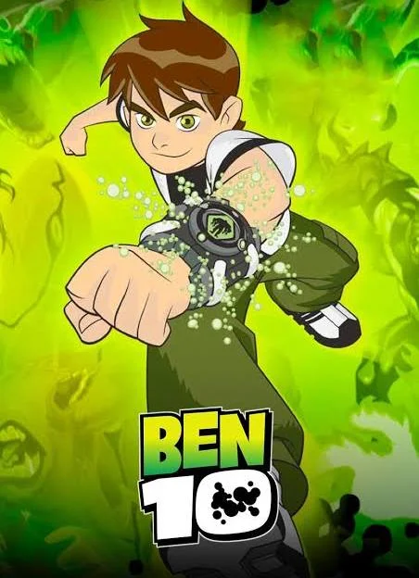
Answer
Question 2:

Clue 1: His greatest advantage comes from something
he can consume, but it is not a magic potion.

Clue 2: A peaceful kingdom repeatedly finds itself
depending on one unusually strong child.

Clue 3:His favourite snack is closely connected to his
extraordinary strength.

Clue 4: He protects a village called Dholakpur.

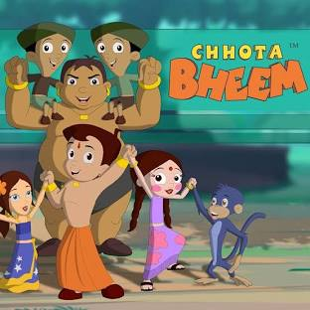

Question 3:
Clue 1: A famous archaeologist spends his life searching for ancient objects, but his discoveries often bring dangerous magic and villains into the modern world.
Clue 2 : He is supported by an energetic young niece who is always ready to join missions, even when he tells her to stay safe.

Clue 3 :
Many adventures involve powerful talismans that give people special abilities when they are collected.

Clue 4 :
He works with Uncle, Jade, and Section 13 to defeat the Dark Hand.

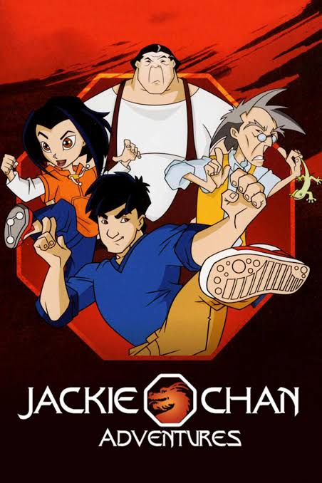

Question 4 :
Clue 1: A determined house guardian spends nearly every day trying to remove one small visitor who is cleverer than he appears.
Clue 2 : Their battles regularly involve traps, frying pans, broken furniture, and chases that somehow destroy the entire house.

Clue 3 : Although they are enemies most of the time, they occasionally work together when a bigger danger appears.

Clue 4 :One is a cat named Tom, and the other is a mouse named Jerry.
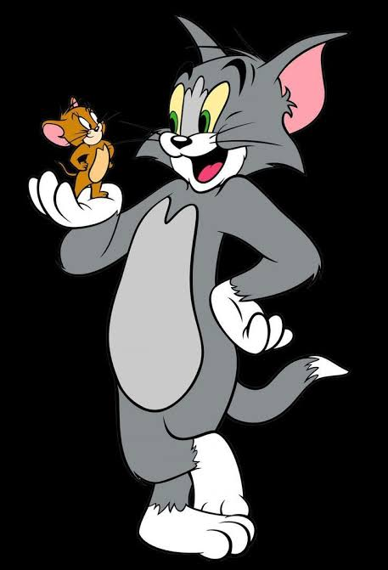

Question 5 :
Clue 1 : Two best friends live in a colourful town and always get into funny adventures.

Clue 2 : One friend is strong but loves eating food more than anything else.

Clue 3 : The other friend is clever and helps solve problems with smart ideas.
The strong friend gets extra power after eating samosas.

Clue 4 :
They live in Furfuri Nagar and are called Motu and Patlu.

